
`

IBM Z

3932 System Cabling Best Practices (Single Frame)



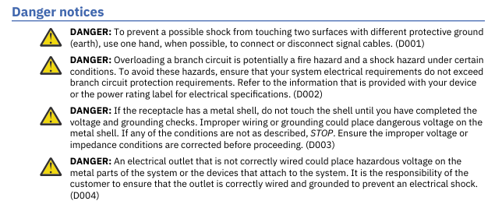
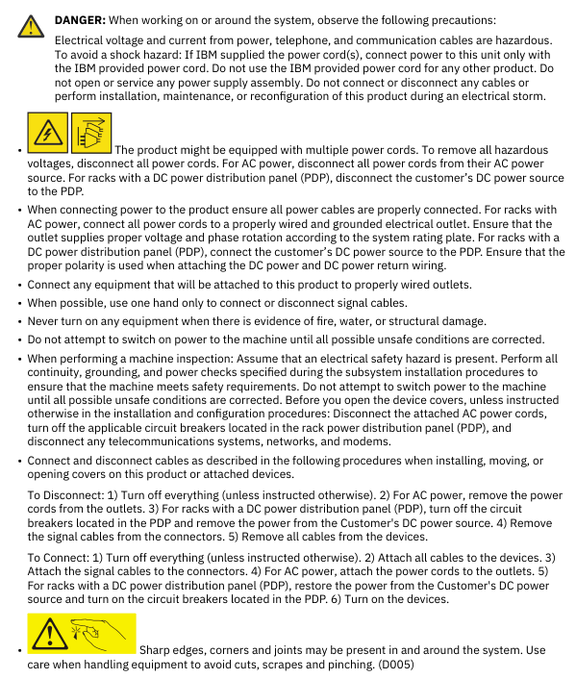

Contents
Chapter 1. Introduction 1
Chapter 2. Line Cords 1
Chapter 3. Cable Support 4
CPC Bracket 4
Clips 5
Hook-and-Loop Fastener 10
Spine 11
Cable Management Bracket 12
Top exit cabling enclosure 14
Line Cord Collar 15
Strain Relief Clamps 15
Chapter 4. Internal System Cables 16
Ethernet Network Cables 16
Power Supply Cords 17
SMP Cables 17
PCIe+ I/O Cable 18
Chapter 5. External System Cables 18
FICON & FCP Cables 18
OSA Network Cables 23
External Ethernet 25
Time Synchronization 25
Appendix A. Notices 28
Trademarks 29
Class A Notices 29

Chapter 1. Introduction
This cabling best practices document was created to help the reader lay out and retain cables for the mainframe. This document includes information for both internal and external cables to assist in both the initial system installation, system upgrades as well as external connections. Here, internal cables are those considered to remain within the system’s confines while external cables are considered cables that leave a frame. To ensure system reliability and serviceability, the reader must follow the contents of this document. It serves as a supplement for the Installation Manual for Physical Planning (IMPP). For essential information including, but not limited to, safety notices, specifications, power requirements, and hardware management, refer to the IMPP. STP and Visio files are also available as visualization tools.

Chapter 2. Line Cords

Line cords are used to power the system through intelligent Power Distribution Units (iPDU). The line cord is designed to exit straight out of the connector then bend with a given minimum bend radius towards the top or bottom of the frame depending on the desired system frame exiting orientation. Cables can exit through the top of the frame using one of the following feature codes: FC 7898 - Top Exit Cabling feature with Enclosure or FC 7928- Top Exit Cabling feature without Enclosure. Cables that leave the frame through the bottom would use feature code FC 7899 - Bottom Exit Cabling feature. For cabling configurations where two line cords are on one side of a frame, the cables are to be routed parallel to each other as they run either up or down.

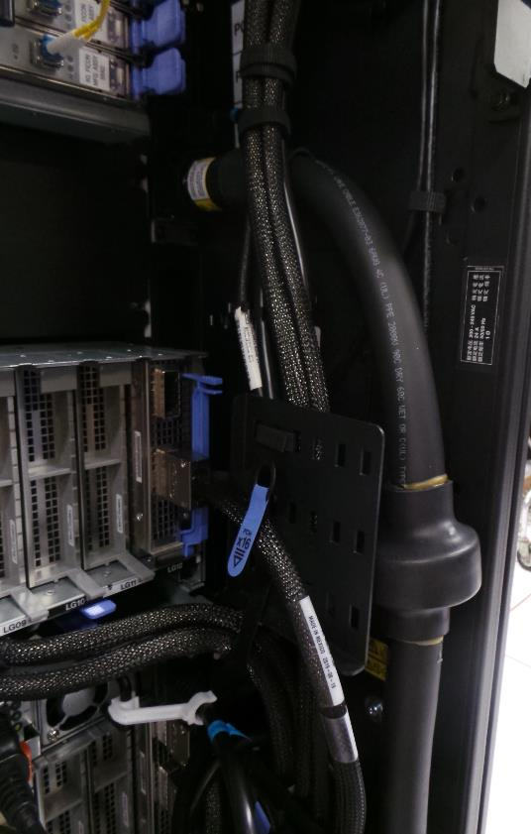
Line Cord
Figure 1: Bottom Exiting Line Cord (FC 7899)

For a top exit system without an enclosure, the space above the system should be clear with sufficient physical space for the line cords to exit the system. In this case, the line cords would be routed directly out the top corners of the frame then plugged at the customer end. A top exit system with an enclosure (FC 7898) is used for both line cords and external system cables exit. It similarly goes through the top of the frame. However, they are routed within the enclosure either towards the system front or rear, and then exit out in the middle section of the enclosure (ref. Fig. 3).

Line Cords

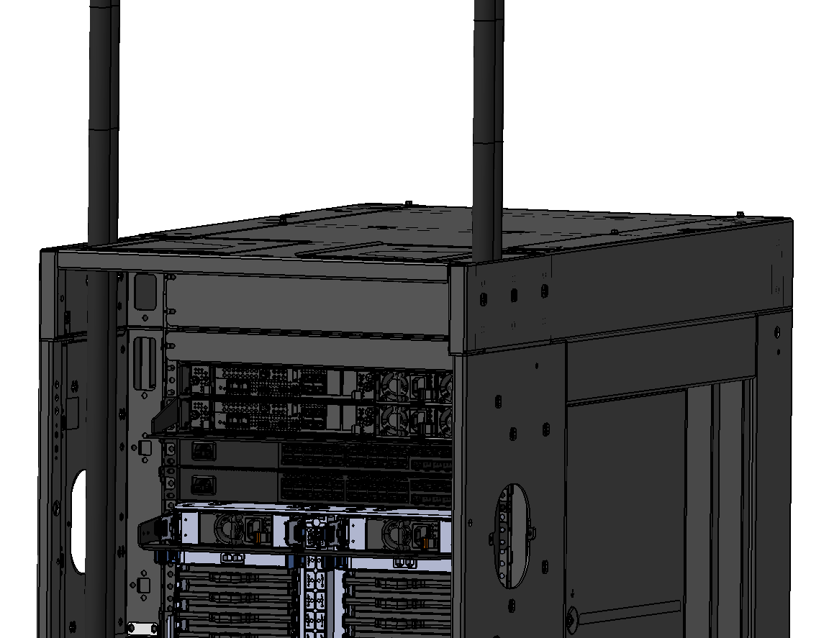

Figure 2: Top Exiting Line Cords without an Enclosure (FC 7928)

Line Cords

Cabling Enclosure
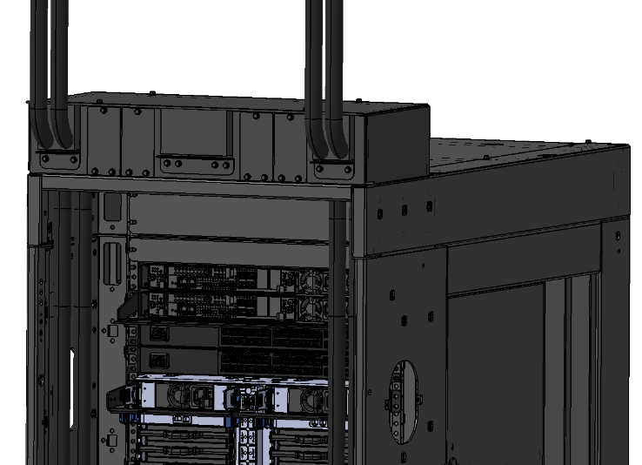

Figure 3: Line Cords in a Top Exit Cabling Enclosure (FC 7899)

For bottom exit systems (FC 7899), the line cord is routed directly to the bottom corners of the system and plugged at the customer end. Line cords should be affixed and strain relieved to the tailgate using the provided bracket(s). Note: Cable slack must be left to allow for a service loop under the floor. This helps with cable maneuverability.

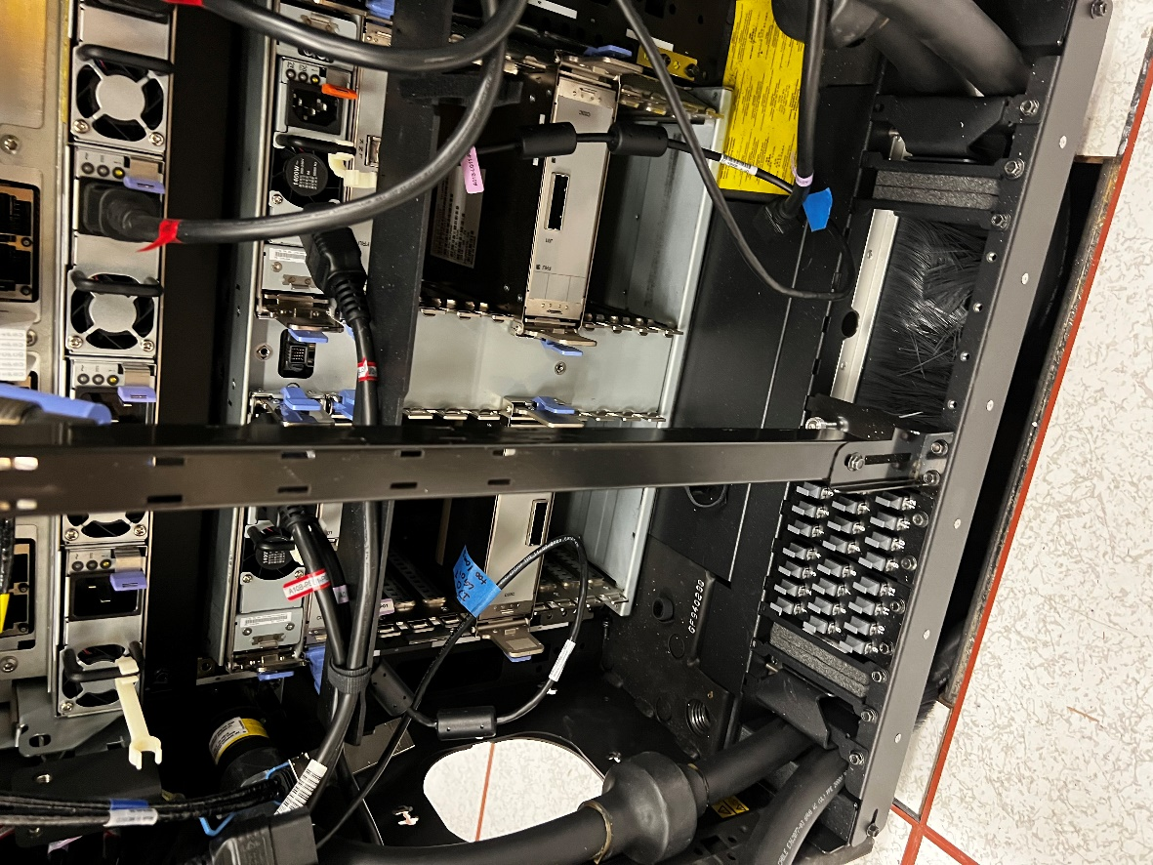
Line Cords
Figure 4: Bottom Exiting Line Cords (FC 7899)

Chapter 3. Cable Support

CPC Bracket

These brackets are used to manage Peripheral Component Interconnect express+ (PCIe+) I/O cables and Symmetric MultiProcessing (SMP) cables that attach to the Central Processor Complex (CPC) drawer. The slots on the CPC bracket are intended for hook-and-loop fasteners to be laced through. The hook-and-loop fastener in turn holds the cables.

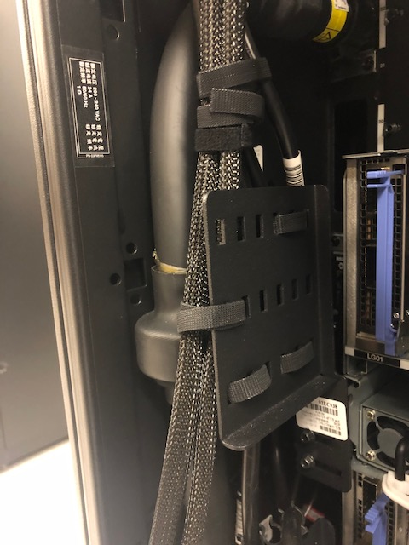
CPC Bracket
Figure 5: CPC Bracket

Clips

There are five types of cable support clips:
- Spine/mini spine hardware clip (reference Figure 6),
- Frame Side clip (reference Figure 7),
- Frame edge clip (reference Figure 8),
- Hook-and-loop fastener clips (reference Figure 9).
- Small Power Supply Unit Clip (reference Figure 10 and 11).

Note, the spine clips are intended to retain external cabling, while the other clips are used to route power supply cords, ethernets, and/or fanout cables flat against the side of the frame.

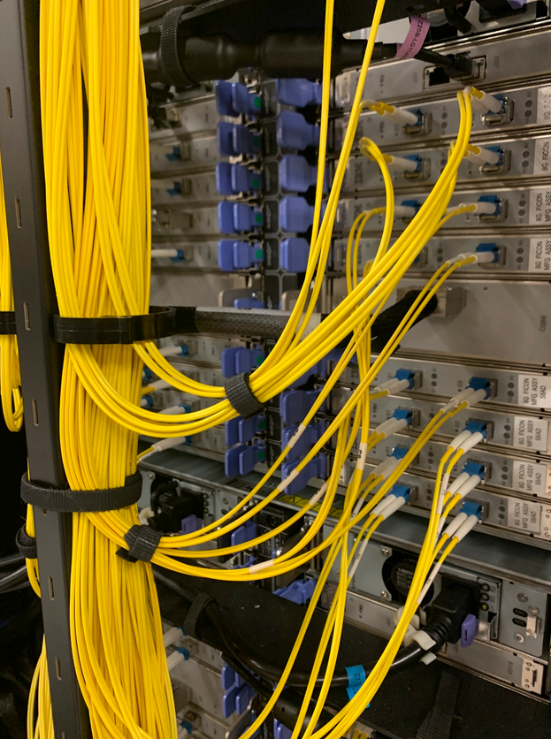
Spine Clip
Figure 6: Spine Clips

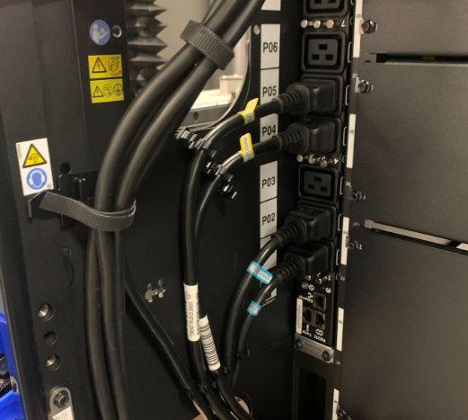
Frame Side Clip
Figure 7: Frame Side Clip

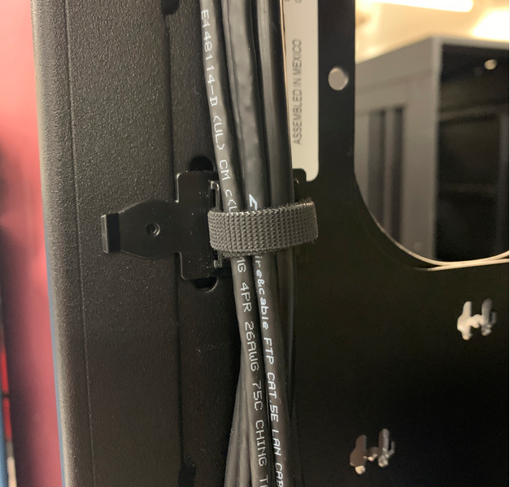
Frame Edge Clip
Figure 8: Frame Edge Clip

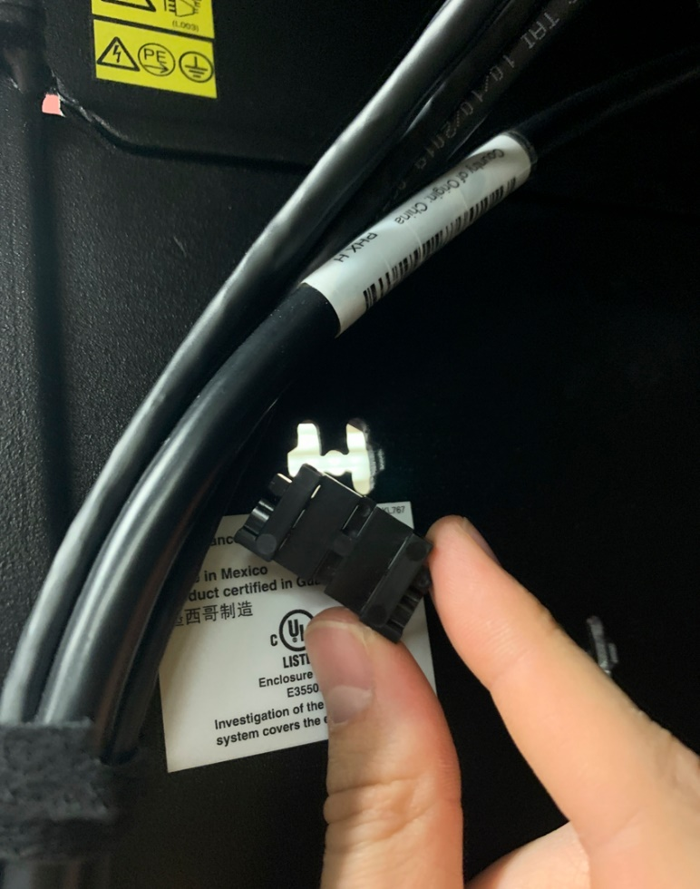
Hook and Loop Fastener Clip
Figure 9: Hook and Loop Fastener Clip

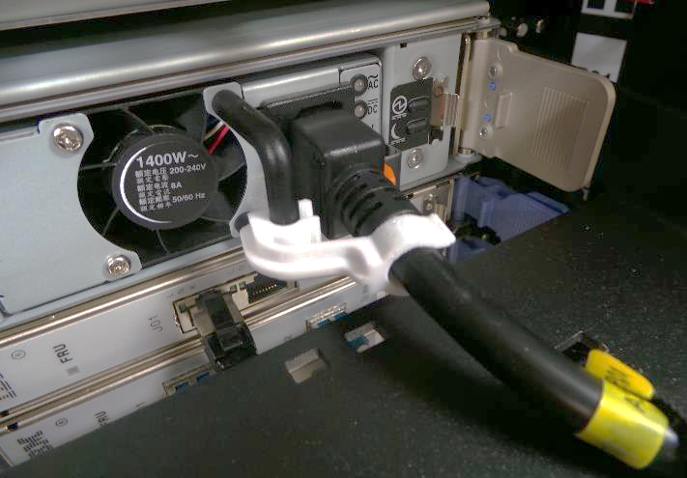
Figure 10: Small Power Supply Unit Clip

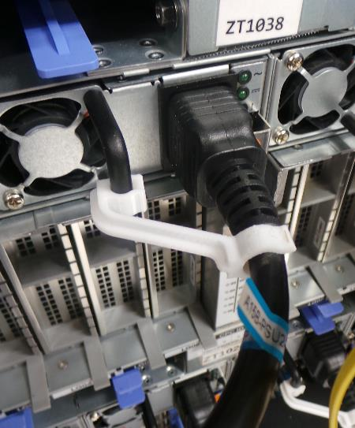
Figure 11: Large Power Supply Unit Clip

Hook-and-Loop Fastener

Hook-and-loop fasteners are used to properly route and retain cables in place, while maintaining bend radii and strain relief. Figure 10 shows what hook-and-loop fasteners look like, and Figure 12 shows how it is used to keep bend radii.

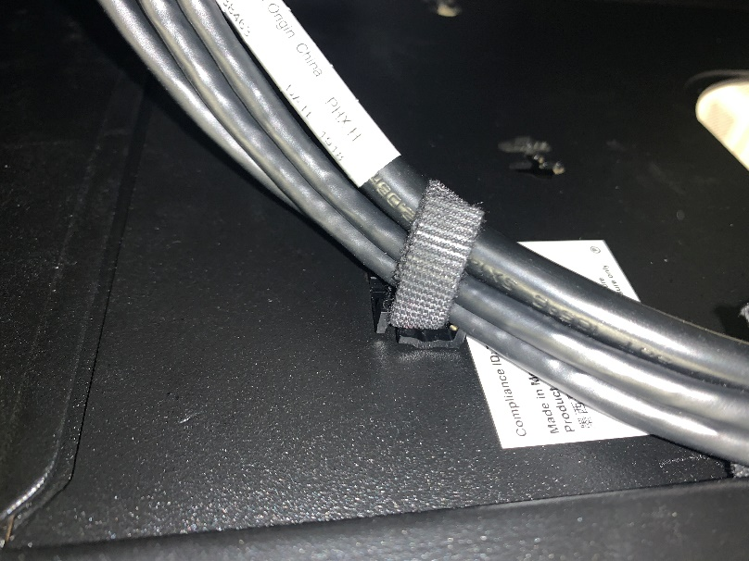
Hook-and-Loop Fastener
Figure 12: Hook-and-Loop Fastener

Spine

The spine is used to route external cables either up or down. It’s provided when 2 CPC drawers or more than two PCIe+ I/O drawers are installed within the frame.

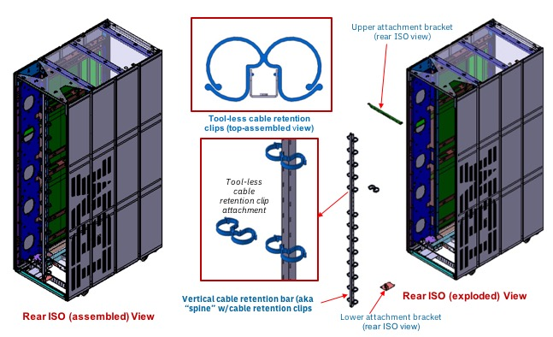
Figure 13: Spine

Cable Management Bracket

The cable management bracket provides service clearance for units above and below these cables and improve iPDU serviceability. There is one located in front of every PCIe+ I/O drawer.

Cable Management Bracket
Hook-and-Loop Fastener

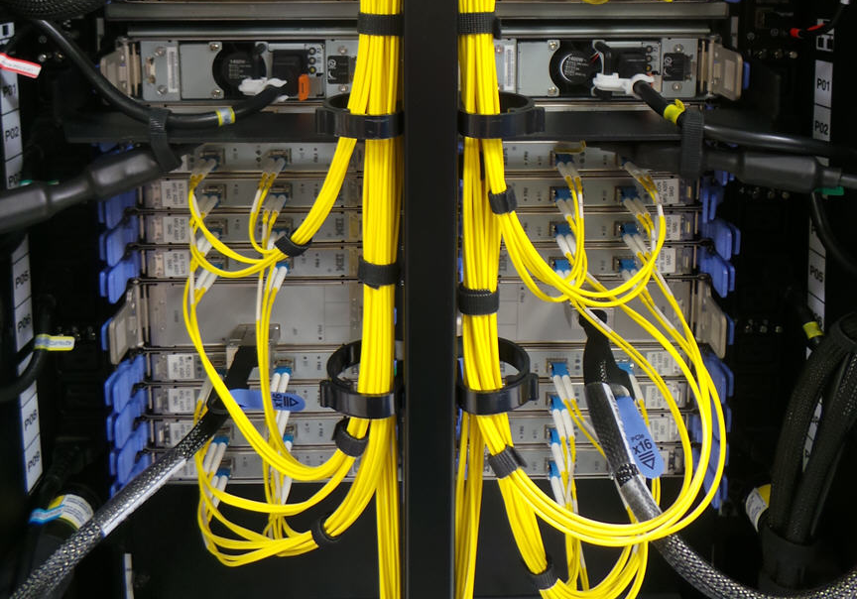
Figure 14: PCIe Drawer Cable Management Bracket (Front View)

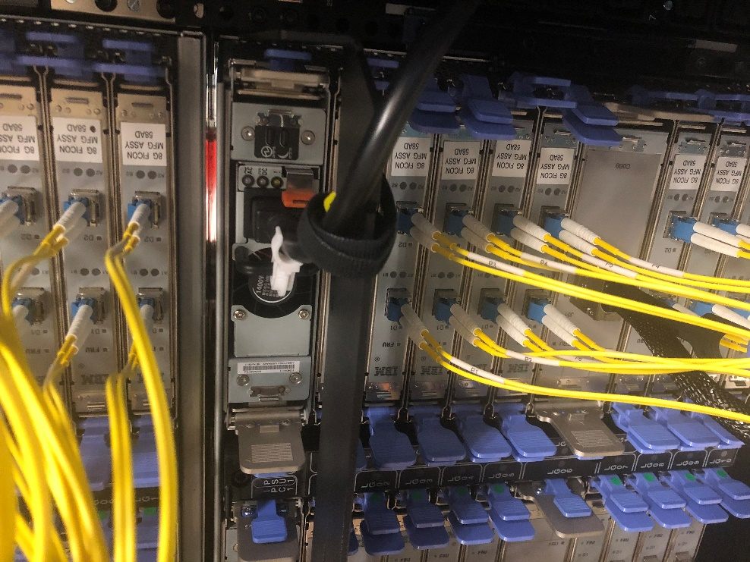
Figure 15: PCIe Drawer Cable Management Bracket (Angled View)

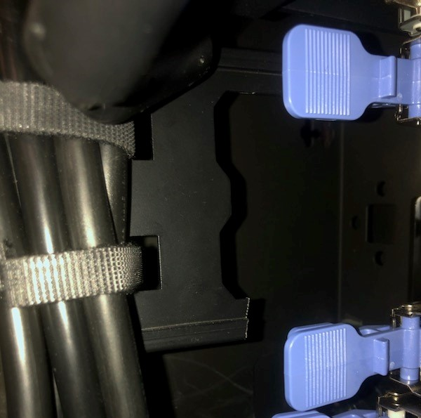
Vertical Cable Management Bracket
Figure 16: Vertical Cable Management Bracket (Angled View)

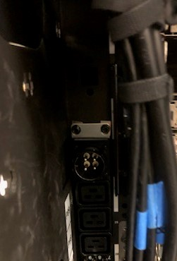
Figure 17: Vertical Cable Management Bracket Showing Clearance to Line Cord Connector

Top exit cabling enclosure

The top exit cabling feature with enclosure (FC 7898) is optional. Any top exiting external cables can be stored here.

Cabling Enclosure
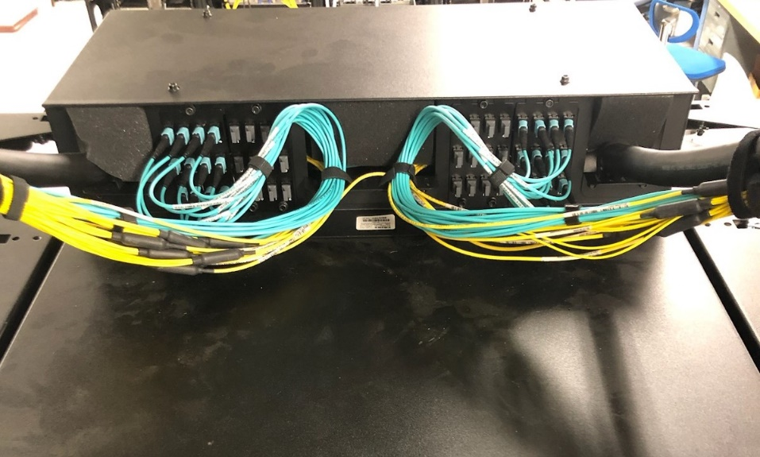
Figure 18: Fiber Cables in Top Exit Cabling Enclosure (FC 7898)

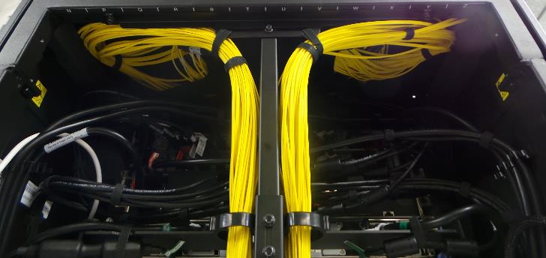
Added clip and hook-and-loop fastener for support
Figure 19: Horizontal Cable Support

Line Cord Collar
The purpose of the line cord collar is to help the user plug the line cord. Its tab is used to actuate the line cord into a secure position using a 14-in socket extension tool.

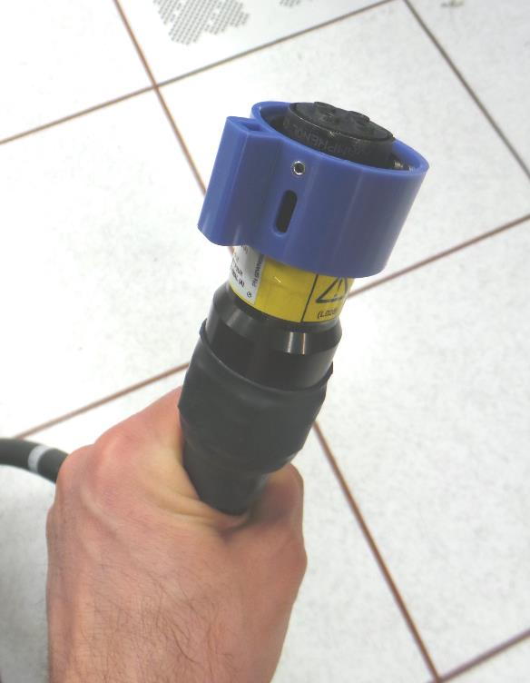
Line Cord Collar
Figure 20: Horizontal Cable Support

Strain Relief Clamps

Strain relief clamps are used to secure cables that pass through the tailgate.

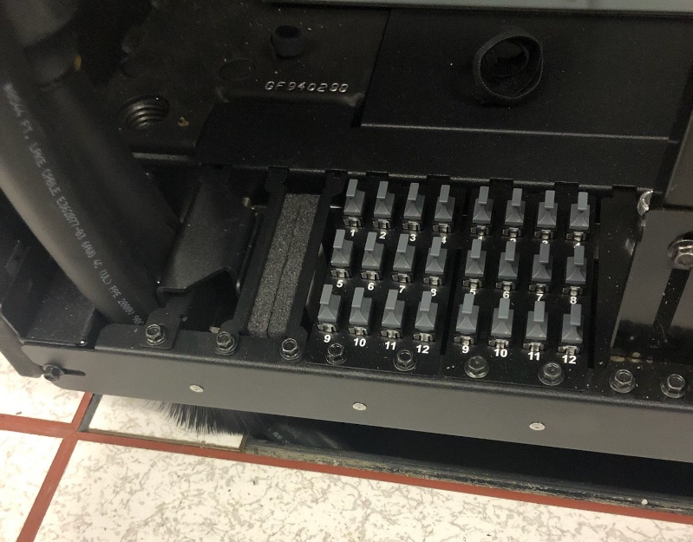
Strain Relief Clamp
Figure 21: Fiber Optic Cables in Strain Relief Clamp for Bottom Exiting System

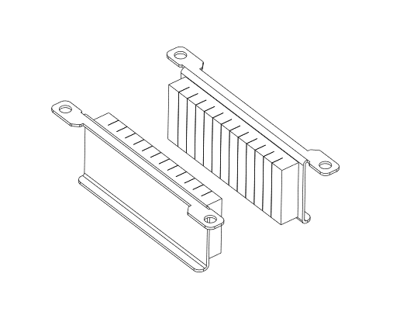

Figure 22: Strain Relief Clamp

Chapter 4. Internal System Cables

Signal and power cables are routed within a frame. For each cable, there is a striped or solid location flag label for guidance as to where the cable should be plugged. The color on the labels serves as a visual aid to distinguish entities from each other. The solid indicates the primary source and the stripe indicates the secondary source. Operators should read the printed label data to ensure the correct plugging location. The subsequent sections are ordered the same way the cables are to be installed.

Ethernet Network Cables

Internal system ethernet network cables interconnect the system’s internal service processor network. Some ethernet cables will have two (2) ferrite cores, and others will not. External ethernet cables will be discussed later in this document.

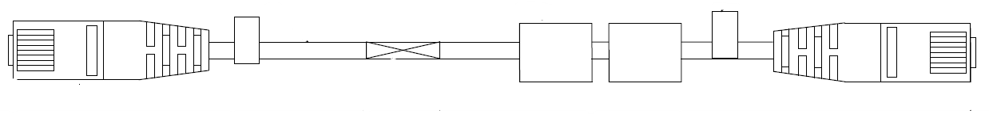
Figure 23: 2D Drawing of an Ethernet Cable

Power Supply Cords
Power supply cords (a.k.a., internal power jumpers) are internal system cables used to connect the internal power supply units to the system’s power distribution system.

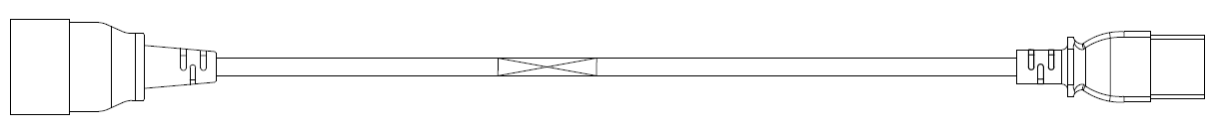
Figure 24: 2D Drawing of a Power Supply Cord

SMP Cables

The SMP cables create the processor network by connecting the nodes of the CPC drawer.

Note: For iPDU service actions, the hook-and-loop fastener that attaches the SMP cable to the CPC bracket will need to be removed to release the cable, so they can be moved out of the way during servicing. DO NOT unplug the cable, but gently move it aside to make clearance for service activities.

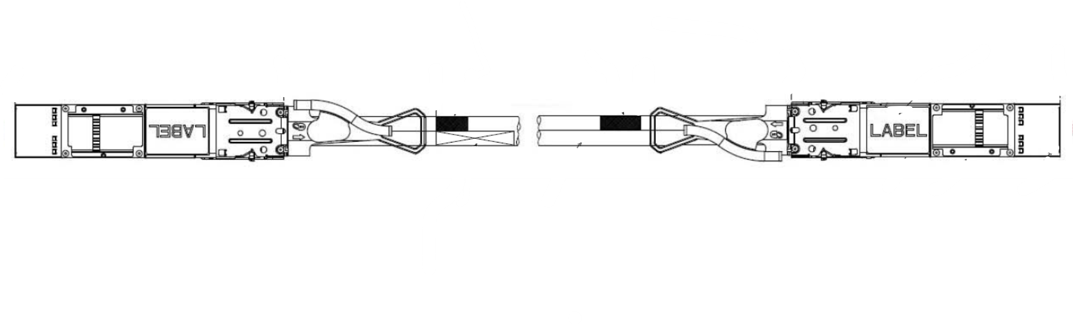
Figure 25: 2D Rendering of SMP Cable

PCIe+ I/O Cable

PCIe+ I/O cables connect the CPC drawers to the PCIe+ I/O drawers.

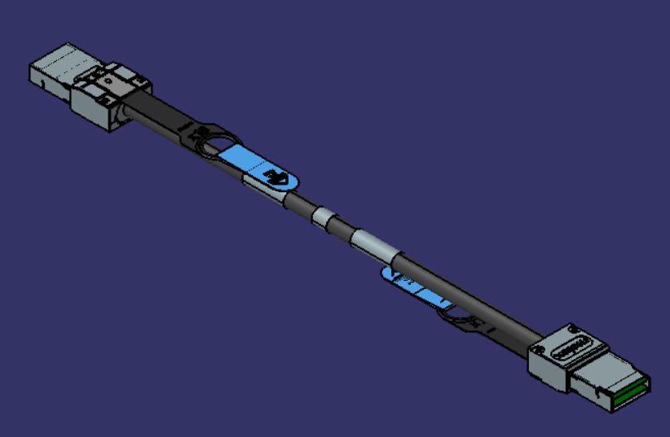
Figure 26: 3D Rendering of a PCIe+ I/O Cable

Chapter 5. External System Cables

FICON & FCP Cables

Fiber optic cables that attach to PCIe+ I/O cards can exit through the top or the bottom of the frame. FICON Express, OSA Express, and Coupling connection types are included in this grouping for further details on the connection type options, refer to the IMPP chapter on I/O Cabling and Connectivity. For planning, there is a Planning for Fiber Optic Links document available on Resource Link.

Two important notes should be understood when installing fiber optic cables:

- Follow recommended cleaning and installation procedures for all fiber optic cable products for optimal performance
- Top exit feature with enclosure (FC 7898) is not required to route fiber optic cables through the top of the machine.

When the spine with the hook-and-loop fasteners are included with the system configuration (i.e., factory-installed or included as part of a system upgrade), it is used for cable management and strain relief. This will route the cables up or down, parallel to the central channel when there are greater than two PCIe+ I/O drawers for both top and bottom exiting systems respectively. Ordering two CPC drawers also drives this. If the Fiber Quick Connect feature (FC 7960) is selected, the cable positions on the bracket should be populated from the center outwards towards the sides of the frame (ref. Figure 25). If Fiber Quick Connect is not selected, then the cables would run through the tailgate or straight out the top of the system for bottom and top exiting cabling schemes, respectively (ref. Figure 17).

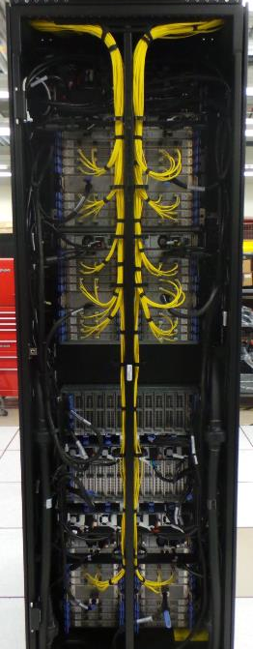
FICON Cables
Figure 27: FICON Cables in Spine (FC 7898)

For frames that don’t have a spine, the fiber optic cables should be evenly distributed along the side of the frame and secured with a hook-and-loop fasteners after approximately every 7 inches (ref. Figure 25).

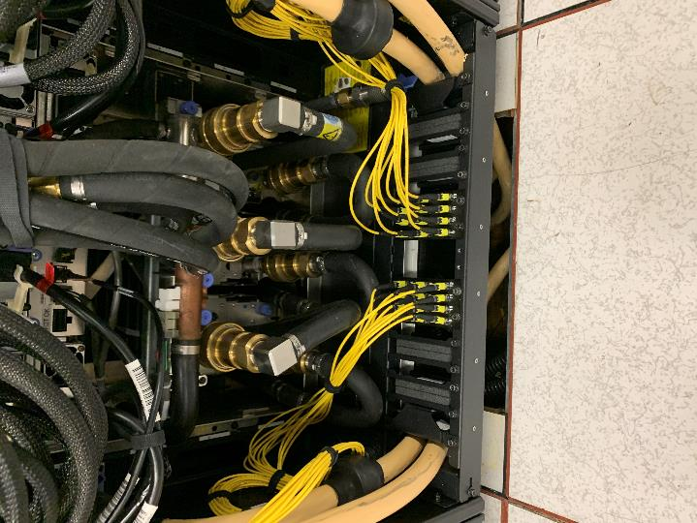
Figure 28: Fiber Optic Cables without a Spine (FC 7899)

The Fiber Quick Connect is used with fiber trunking cables and, in this case, the system is provided with the bracket, connectors, and filler plates. The filler plates must be installed if a bracket slot is empty to minimize system airflow recirculation. When the Fiber Quick Connect system is ordered with the top exit cabling enclosure feature, the brackets are mounted in the enclosure per Figure 27. When using this FC, to minimize cabling congestion within the frame confines, it is recommended that all excess fiber cabling bulk be trained upward and spooled with the box structure mounted on the top of the frame (ref. Figure 28).

Fiber Quick Connect
Figure 29: Fiber Quick Connect on Tailgate (FC 7899)

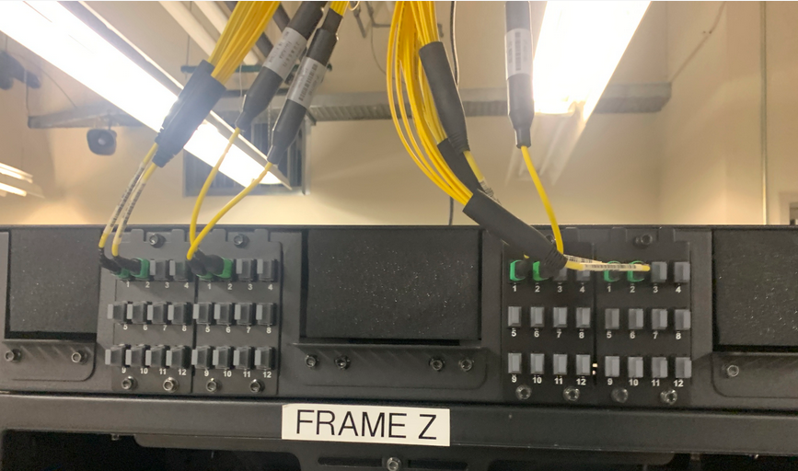
Fiber Quick Connect
Fiber Quick Connect
Figure 30: Fiber Quick Connect in Top Exit Cabling Enclosure (FC 7898)

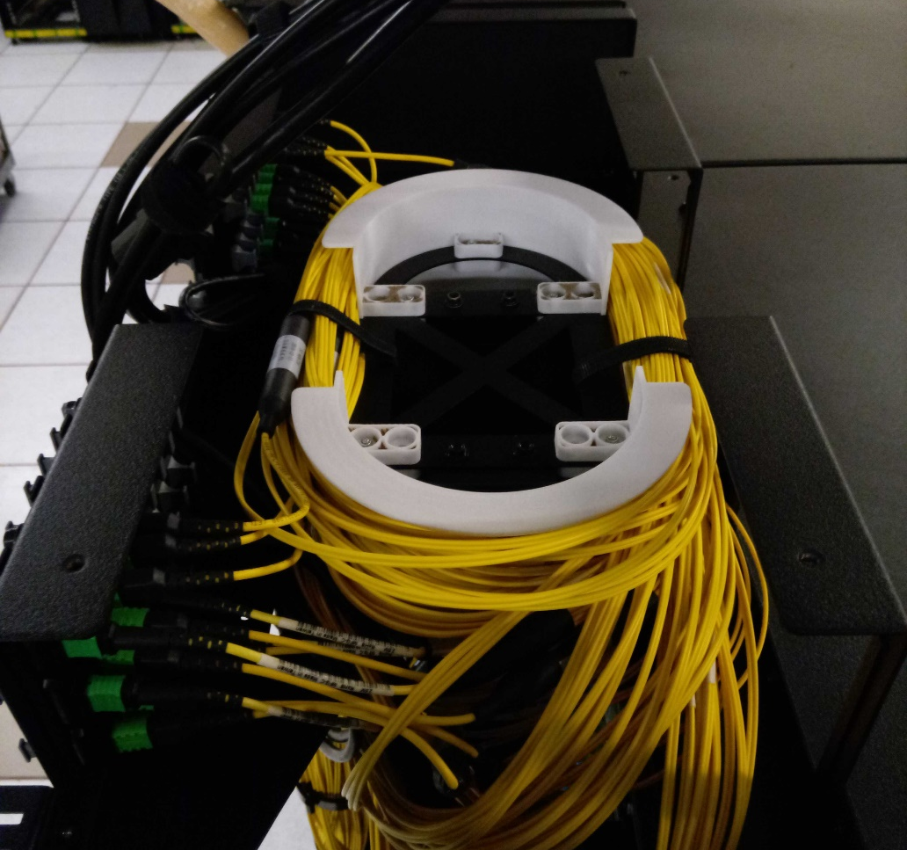
Figure 31: Fiber Cables in Top Exit Cabling Enclosure

NOTE: The coupling cables originating from CPC drawer(s) should be routed first to the side of the frame and then either up or down depending on the defined system cabling exit scheme (ref. Figure 29).

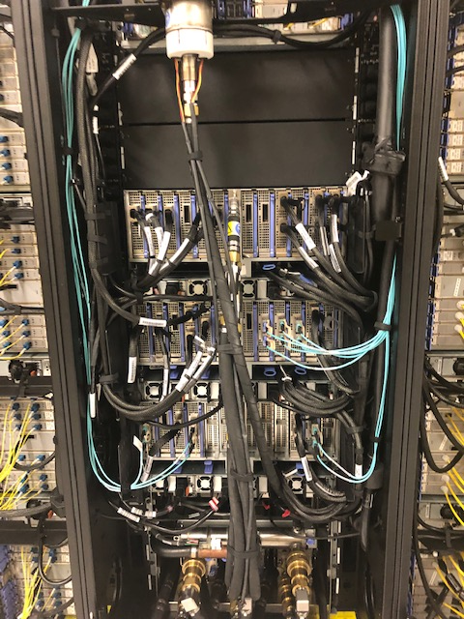
Figure 32: Coupling Cabling with Hook-and-Loop Fasteners

Lastly, every cable should be terminated, retained and supported properly with strain relief clamps, cable clamps, and filler plates. This will ensure the cable performs reliably and preserves its integrity.

OSA Network Cables

Open Systems Adapter-Express (OSA-Express) features enable connectivity to industry-standard local area networks (LANs). These cables may either be copper or fiber optic. They are to be routed through the spine. Configuration information is found in the IMPP and reference information is found in the Planning for Fiber Optic Links.

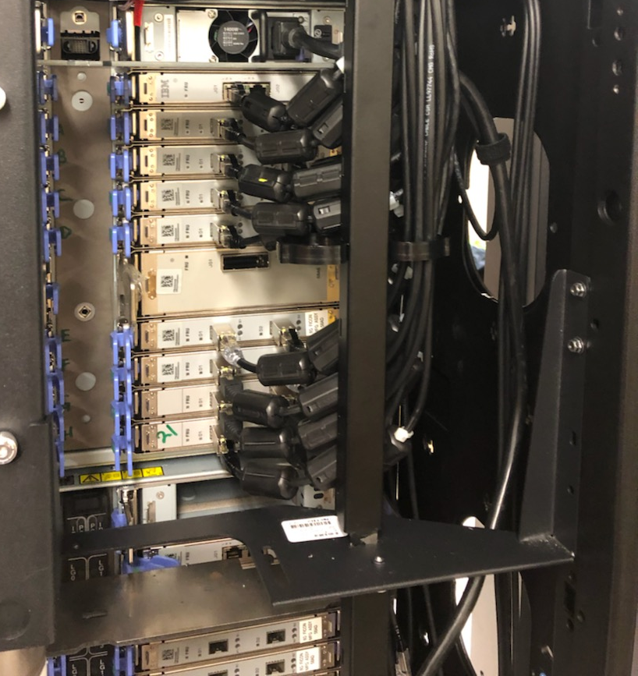
Figure 33: OSA Cables in Mini-Spine

External Ethernet

There are two (2) 50-foot external ethernet cables provided that connect the Support Element (SE) to the Hardware Management Console (HMC). These cables are to be routed to the left of the server then exit either from the top or the bottom depending on the external cabling configuration.

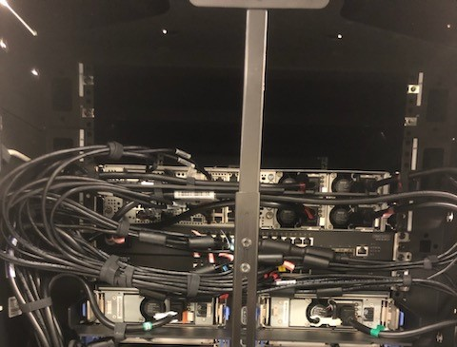
Figure 34: External Ethernet Routing

Time Synchronization

A Server Time Protocol (STP) Coordinated Timing Networks (CTN) has the capability of connecting to its time source a Network Time Protocol (NTP) time server that has a pulse per second (PPS) output signal. This type of external timing device is connected using a coaxial cable to the front of the CPC drawer located within the frame (reference Figures 32 and 33). The cable should be retained to the FSP card latches using hook-and-loop fasteners. The routing of these cables shall be along the same path as the preinstalled FSP ethernet cables under the plastic cable organizer in front of the frame (ref. Figure 34). After it is routed through the horizontal hole in the upper portion of the frame, it goes either up or down out of frame depending on the desired external cabling configuration. If top exiting cabling is being used, the coaxial cable may also be exited from the top through the D-hole in the upper portion of the front of the frame (see Figure 35).

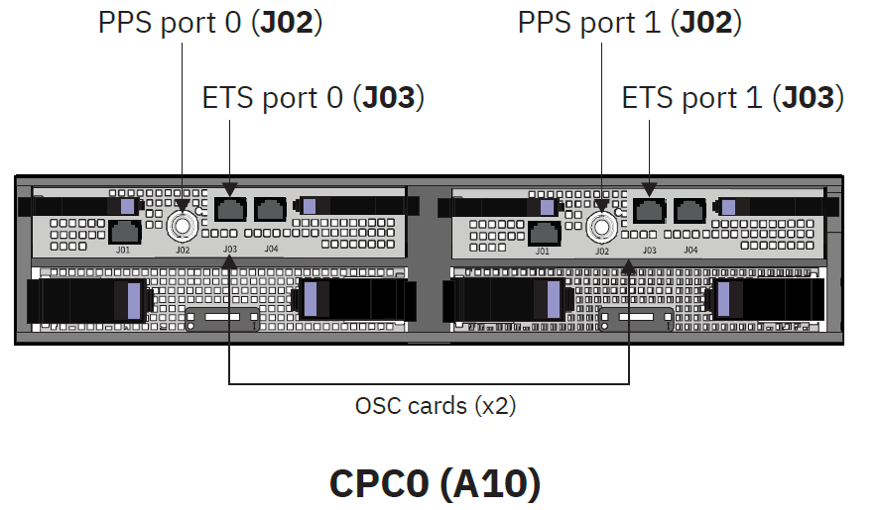
Figure 35: PPS Ports for One (1) CPC drawer

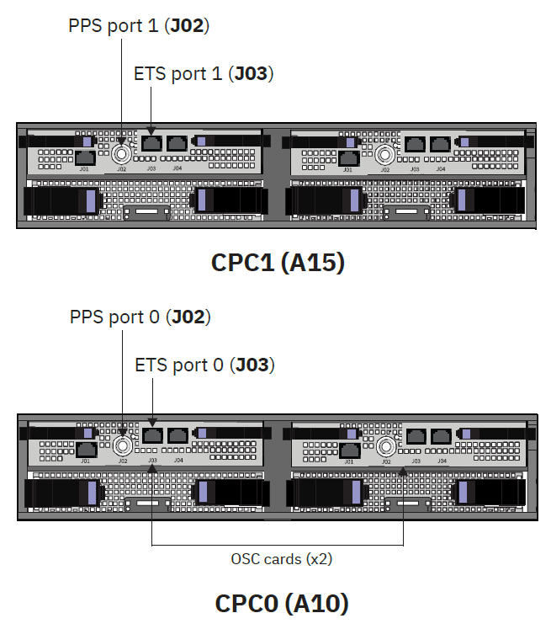
Figure 36: PPS Ports for Two (2) CPC drawers

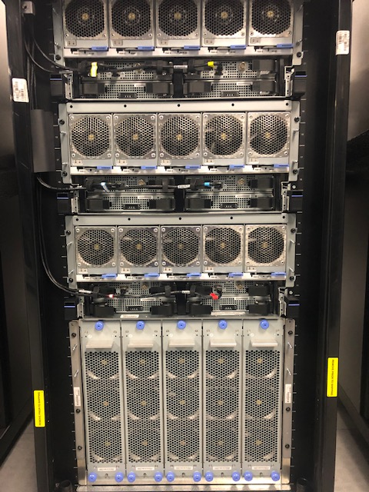
Plastic Cable Organizer
Figure 37: Front of CPC Drawer

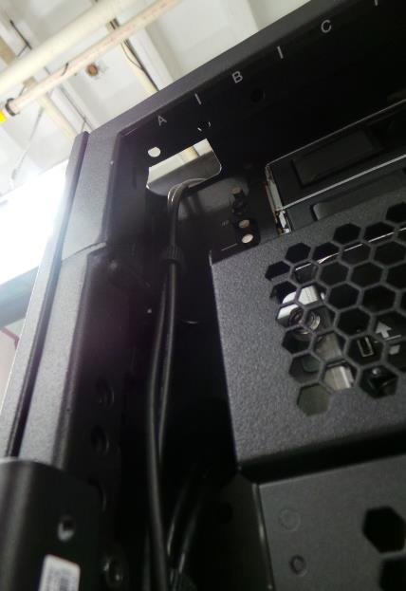
D Hole
Figure 38: D Hole

Appendix A. Notices

This information was developed for products and services offered in the US.
IBM may not offer the products, services, or features discussed in this document in other countries. Consult your local IBM representative for information on the products and services currently available in your area. Any reference to an IBM product, program, or service is not intended to state or imply that only that IBM product, program, or service may be used. Any functionally equivalent product, program, or service that does not infringe any IBM intellectual property right may be used instead. However, it is the user's responsibility to evaluate and verify the operation of any non-IBM product, program, or service.
IBM may have patents or pending patent applications covering subject matter described in this document. The furnishing of this document does not grant you any license to these patents. You can send license inquiries, in writing, to:
IBM Director of Licensing
IBM Corporation
North Castle Drive, MD-NC119
Armonk, NY 10504-1785
US
INTERNATIONAL BUSINESS MACHINES CORPORATION PROVIDES THIS PUBLICATION "AS IS" WITHOUT WARRANTY OF ANY KIND, EITHER EXPRESS OR IMPLIED, INCLUDING, BUT NOT LIMITED TO, THE IMPLIED WARRANTIES OF NON-INFRINGEMENT, MERCHANTABILITY OR FITNESS FOR A
PARTICULAR PURPOSE. Some jurisdictions do not allow disclaimer of express or implied warranties in certain transactions, therefore, this statement may not apply to you.
This information could include technical inaccuracies or typographical errors. Changes are periodically made to the information herein; these changes will be incorporated in new editions of the publication. IBM may make improvements and/or changes in the product(s) and/or the program(s) described in this publication at any time without notice.
Any references in this information to non-IBM websites are provided for convenience only and do not in any manner serve as an endorsement of those websites. The materials at those websites are not part of the materials for this IBM product and use of those websites is at your own risk.
IBM may use or distribute any of the information you provide in any way it believes appropriate without incurring any obligation to you.
Information concerning non-IBM products was obtained from the suppliers of those products, their published announcements or other publicly available sources. IBM has not tested those products and cannot confirm the accuracy of performance, compatibility or any other claims related to non-IBM products. Questions on the capabilities of non-IBM products should be addressed to the suppliers of those products.
Statements regarding IBM's future direction or intent are subject to change or withdrawal without notice, and represent goals and objectives only.
This information contains examples of data and reports used in daily business operations. To illustrate them as completely as possible, the examples include the names of individuals, companies, brands, and products. All of these names are fictitious and any similarity to actual people or business enterprise is entirely coincidental.

Trademarks
IBM, the IBM logo, and ibm.com® are trademarks of International Business Machines Corp., registered in many jurisdictions worldwide. Other product and service names might be trademarks of IBM or other companies. A current list of IBM trademarks is available on the web at "Copyright and trademark information" at http://www.ibm.com/legal/copytrade.
Linux is a registered trademark of Linus Torvalds in the United States, other countries, or both.
Microsoft and Windows are trademarks of Microsoft Corporation in the United States, other countries, or both.

Class A Notices
The following Class A statements apply to this IBM product. The statement for other IBM products intended for use with this product will appear in their accompanying manuals.

Federal Communications Commission (FCC) Statement
Note: This equipment has been tested and found to comply with the limits for a Class A digital device, pursuant to Part 15 of the FCC Rules. These limits are designed to provide reasonable protection against harmful interference when the equipment is operated in a commercial environment. This equipment generates, uses, and can radiate radio frequency energy and, if not installed and used in accordance with the instruction manual, may cause harmful interference to radio communications. Operation of this equipment in a residential area is likely to cause harmful interference, in which case the user will be required to correct the interference at his own expense.
Properly shielded and grounded cables and connectors must be used in order to meet FCC emission limits. IBM is not responsible for any radio or television interference caused by using other than recommended cables and connectors or by unauthorized changes or modifications to this equipment. Unauthorized changes or modifications could void the user's authority to operate the equipment.
This device complies with Part 15 of the FCC rules. Operation is subject to the following two conditions:
- this device may not cause harmful interference, and (2) this device must accept any interference received, including interference that may cause undesired operation.

Industry Canada Compliance Statement
This Class A digital apparatus complies with Canadian ICES-003.

Avis de conformité à la réglementation d'Industrie Canada
Cet appareil numérique de la classe A est conforme à la norme NMB-003 du Canada.

European Community Compliance Statement
This product is in conformity with the protection requirements of EU Council Directive 2014/30/EU on the approximation of the laws of the Member States relating to electromagnetic compatibility. IBM cannot accept responsibility for any failure to satisfy the protection requirements resulting from a non- recommended modification of the product, including the fitting of non-IBM option cards.

This product has been tested and found to comply with the limits for Class A Information Technology Equipment according to European Standard EN 55032. The limits for Class A equipment were derived for commercial and industrial environments to provide reasonable protection against interference with licensed communication equipment.
European Community contact:
IBM Deutschland GmbH
Technical Regulations, Department M372 IBM-Allee 1, 71139 Ehningen, Germany
Tele: +49 (0) 800 225 5423 or +49 (0) 180 331 3233
email: halloibm@de.ibm.com
Warning: This is a Class A product. In a domestic environment, this product may cause radio interference, in which case the user may be required to take adequate measures.

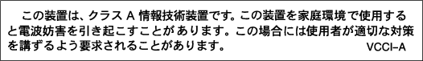
VCCI Statement - Japan
The following is a summary of the Japanese VCCI statement above:
This is a Class A product based on the standard of the VCCI Council. If this equipment is used in a domestic environment, radio interference may occur, in which case the user may be required to take corrective actions.

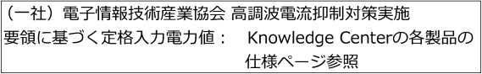
Japan JIS C 61000-3-2 Compliance
For products less than or equal to 20 A per phase, the following statement applies:
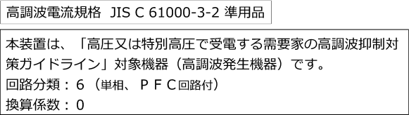
For products greater than 20 A, single-phase, the following statements apply:
For products greater than 20 A per phase, three-phase, the following statements apply:

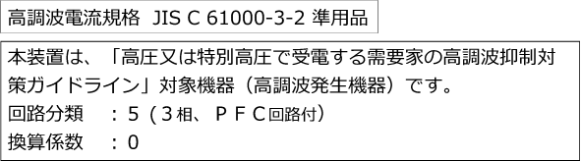

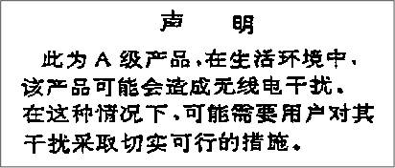
Electromagnetic Interference (EMI) Statement - People's Republic of China

Declaration: This is a Class A product. In a domestic environment, this product may cause radio interference, in which case the user may need to perform practical action.


Electromagnetic Interference (EMI) Statement - Taiwan
The following is a summary of the Taiwan EMI statement above:
Warning: This is a Class A product. In a domestic environment, this product may cause radio interference, in which case the user will be required to take adequate measures.
IBM Taiwan Contact Information:




Electromagnetic Interference (EMI) Statement - Korea

Germany Compliance Statement
Deutschsprachiger EU Hinweis: Hinweis für Geräte der Klasse A EU-Richtlinie zur Elektromagnetischen Verträglichkeit
Dieses Produkt entspricht den Schutzanforderungen der EU-Richtlinie 2014/30/EU zur Angleichung der Rechtsvorschriften über die elektromagnetische Verträglichkeit in den EU-Mitgliedsstaaten und hält die Grenzwerte der EN 55032 Klasse A ein.
Um dieses sicherzustellen, sind die Geräte wie in den Handbüchern beschrieben zu installieren und zu betreiben. Des Weiteren dürfen auch nur von der IBM empfohlene Kabel angeschlossen werden. IBM übernimmt keine Verantwortung für die Einhaltung der Schutzanforderungen, wenn das Produkt ohne Zustimmung von IBM verändert bzw. wenn Erweiterungskomponenten von Fremdherstellern ohne Empfehlung von IBM gesteckt/eingebaut werden.
EN 55032 Klasse A Geräte müssen mit folgendem Warnhinweis versehen werden:
"Warnung: Dieses ist eine Einrichtung der Klasse A. Diese Einrichtung kann im Wohnbereich Funk- Störungen verursachen; in diesem Fall kann vom Betreiber verlangt werden, angemessene Maßnahmen zu ergreifen und dafür aufzukommen."
Deutschland: Einhaltung des Gesetzes über die elektromagnetische Verträglichkeit von Geräten
Dieses Produkt entspricht dem "Gesetz über die elektromagnetische Verträglichkeit von Geräten (EMVG)". Dies ist die Umsetzung der EU-Richtlinie 2014/30/EU in der Bundesrepublik Deutschland.
Zulassungsbescheinigung laut dem Deutschen Gesetz über die elektromagnetische Verträglichkeit von Geräten (EMVG) (bzw. der EMC EG Richtlinie 2014/30/EU) für Geräte der Klasse A
Dieses Gerät ist berechtigt, in Übereinstimmung mit dem Deutschen EMVG das EG-Konformitätszeichen - CE - zu führen.
Verantwortlich für die Einhaltung der EMV Vorschriften ist der Hersteller: International Business Machines Corp.
New Orchard Road Armonk, New York 10504 Tel: 914-499-1900
Der verantwortliche Ansprechpartner des Herstellers in der EU ist: IBM Deutschland GmbH
Technical Regulations, Abteilung M372 IBM-Allee 1, 71139 Ehningen, Germany
Tel: +49 (0) 800 225 5423 or +49 (0) 180 331 3233
email: halloibm@de.ibm.com

Generelle Informationen:
Das Gerät erfüllt die Schutzanforderungen nach EN 55024 und EN 55032 Klasse A.

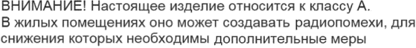
Electromagnetic Interference (EMI) Statement - Russia

